**Fire detection and Alerting system**

**Design:**

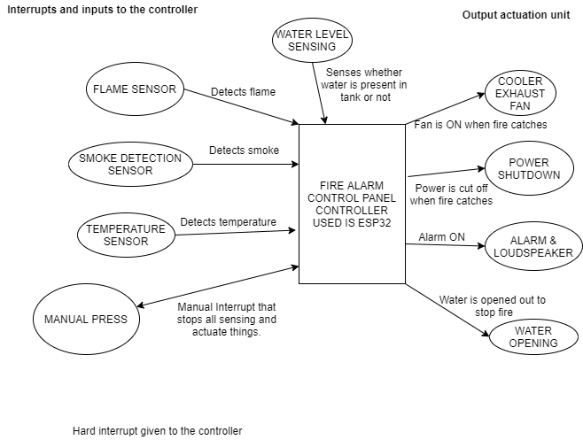

**Hardware modules:**

|  |  |  |
| --- | --- | --- |
| **Components** | **Link** | **Price(Rs)** |
| Flame sensor | Already bought (IR sensor type flame sensor) | 230 |
| Water level sensor (ROBODO - SEN18) | <https://www.amazon.in/Robodo-Electronics-SEN18-Detection-Arduino/dp/B0787HGY19/ref=sr_1_6?dchild=1&keywords=water+level+sensor&qid=1592921197&sr=8-6> | 180 |
| Manual Press (Just a button can be kept) | Offline purchase | - |
| DHT11 Digital Humidity Temperature Sensor | <https://www.amazon.in/DIGITAL-TEMPERATURE-HUMIDITY-COMPATIBLE-Techleads/dp/B07N67VBCL/ref=sr_1_4?dchild=1&keywords=DHT11+Digital+Humidity+Temperature+Sensor&qid=1592922304&sr=8-4> | 190 |
| [MQ-2 Gas Sensor Module](http://www.icstation.com/product_info.php?products_id=3025) | <https://www.amazon.in/Techleads-Sensor-Module-Methane-Detection/dp/B07N696453/ref=sr_1_4?dchild=1&keywords=MQ-2+Gas+Sensor+Module&qid=1592923132&sr=8-4> | 210 |
| Buzzer | Offline purchase |  |
| Exhaust fan (can be shown as normal DC motor) | Available | - |
| LED’s | Available | - |

**Functional requirements:**

* The system should provide more preference to Flame sensor to tell whether fire has occurred or not. Upon the input from flame sensor and other sensors so, based on the sensor values and some threshold the things get actuated.
* The system should behave in such a way that when the manual press is attempted irrespective of any sensor values the things get actuated like water opening, cooler fan, power cut off and alarm all these gets implemented based on the priority given below.
* The system should keep an eye on the water level in the tank all the time and notify when the water level is low.

**Non-Functional requirements:**

* The system should be compact and not occupy much space.
* The system should be time deterministic and there must not be any lag in water opening or flame sensing.

**Logic:**

Here the highest number will be the most priority one

|  |  |  |
| --- | --- | --- |
| **Tasks** | **Name** | **Priorities** |
| Task 1 | Flame sensor & Water level sensor | 10 |
| Task 2 | Smoke sensor & Temperature sensor | 8 |
| Task 3 | Alarm & Water opening & Power shutdown | 9 |
| Task 4 | Cooler ON | 7 |
| Task 5 | Manual Press | 10 |

**Research Gap:**

Different designs were made for fire detection and alarming system focusing on implementing image processing using cameras, adding machine learning to the system. But in our paper the difference is we are trying to understand a gap between C++ and Micropython using a RTOS and it will be real time to understand the characteristics.

**Disclaimer**: No one has done it using MicroPython but they have tried it out using normal python and machine learning so, ours will make some difference.

**Types of fire Detection and alerting system**

* **Conventional:** It is a wired system where the building is divided into different zones and the correct zone which has got fire will be shown in the screen
* **Wireless:** These are wireless system which communicates using radio waves. This is full intelligent fire detection system which doesn’t need any cable.
* **Addressable:** Addressable is same like Conventional but all the detectors are kept in a loop given a certain address using DIP switch. And if fire catches we can get to know in the control panel that which detector has called for the alarm.
* **Intelligent:** Previous systems were not intelligent this system itself tells whether it is a fire or a fault.

**Implementation:**

MQ2 sensor= simple analog read and get the data very simple.

Water level sensor= simply give analog read and set the value for high or low or medium

Humidity and temperature sensor= Library is available and data is coming very simple.

Flame sensor= Simple yes or no digital write.

**References:**

* <https://www.youtube.com/watch?v=cVjyDgFrb2g>
* <http://sspengineering.cn/en/pd.jsp?id=11>
* de Oliveira Turci, Luca. (2017). Real-Time Operating System FreeRTOS Application for Fire Alarm Project in Reduced Scale. International Journal of Computing and Digital Systems. 6. 198-204. 10.12785/IJCDS/060405.
* Buniyamin, Norlida. (2013). Development of Fire Alarm System using Raspberry Pi and Arduino Uno.
* <https://github.com/niladri30/Fire-detection-using-Python>.
* Kulkarni Sangam , T. Prasanna , K. Bramaramba, 2019, An IoT based Fire Detection, Precaution & Monitoring System using Raspberry Pi3 & GSM, INTERNATIONAL JOURNAL OF ENGINEERING RESEARCH & TECHNOLOGY (IJERT) Volume 08, Issue 07 (July 2019),
* <https://www.youtube.com/watch?v=r33s0v68_Qw>